SQL ASSIGNMENT - 1

Creating table named **products**

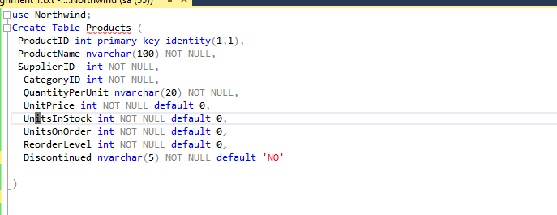

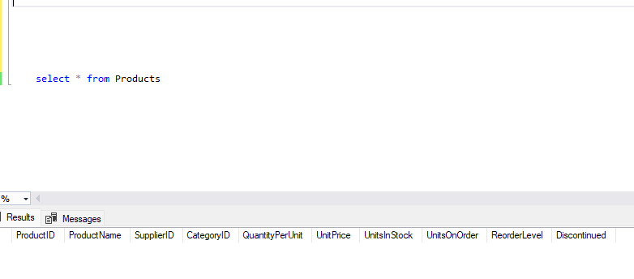

Inserting data into Created Table

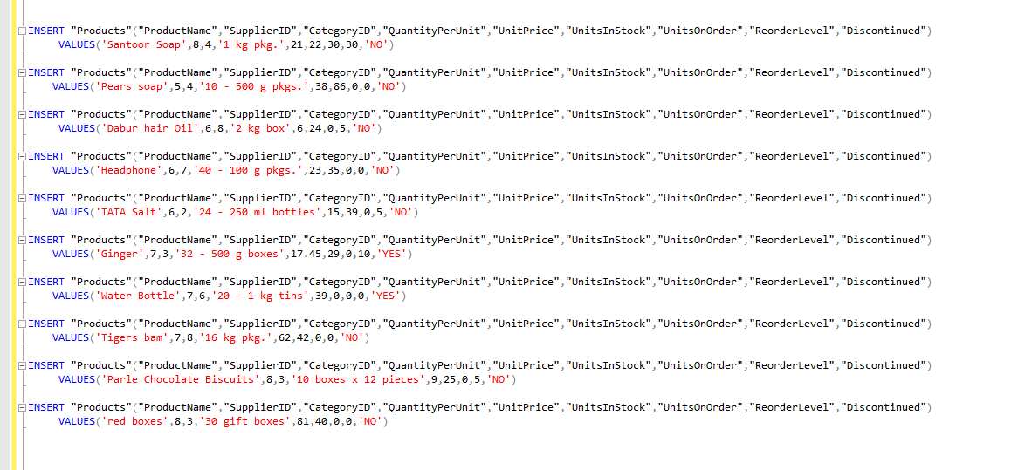

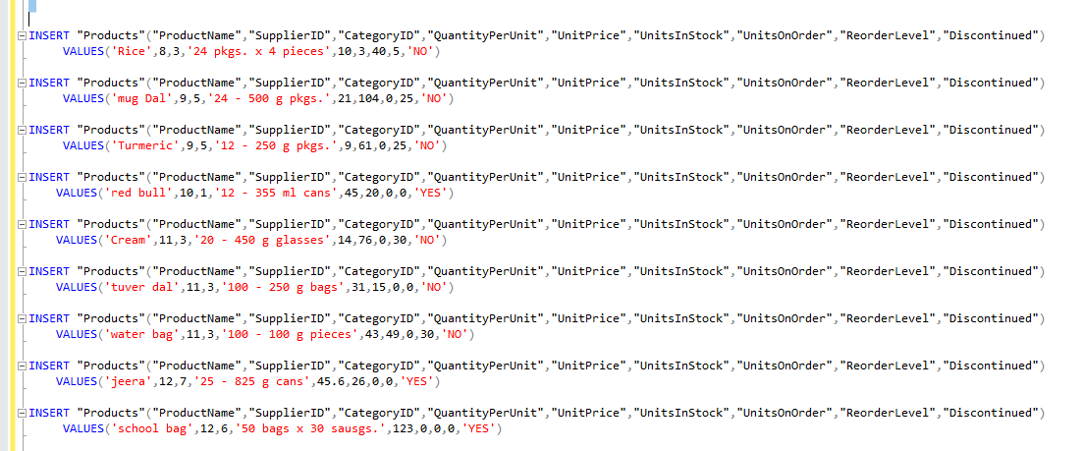

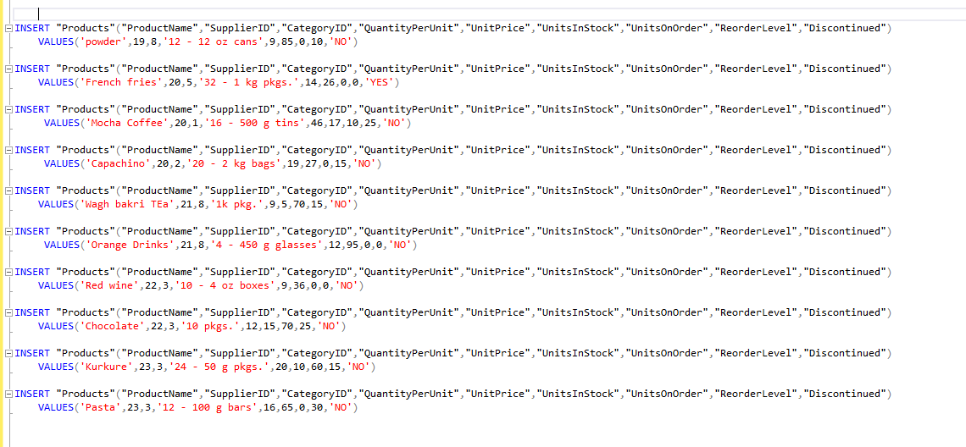

Viewing the Inserted Data:

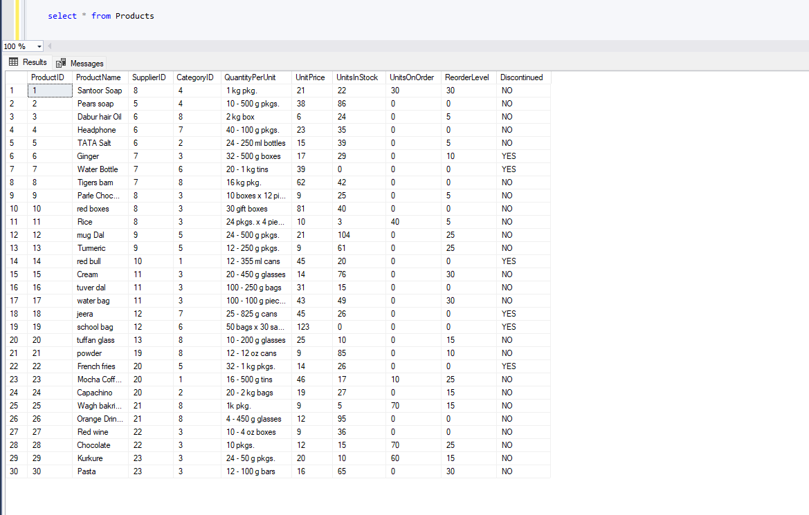

1. Write a query to get a Product list (id, name, unit price) where current products cost less than $20.

→

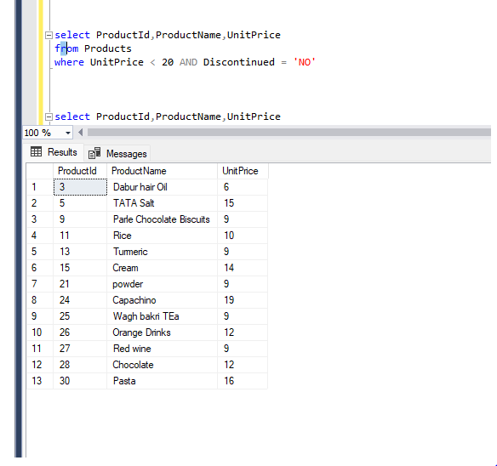

2. Write a query to get Product list (id, name, unit price) where products cost between $15 and $25

-->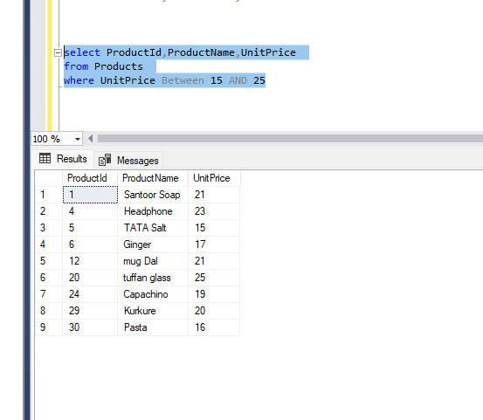

3. Write a query to get Product list (name, unit price) of above average price

-->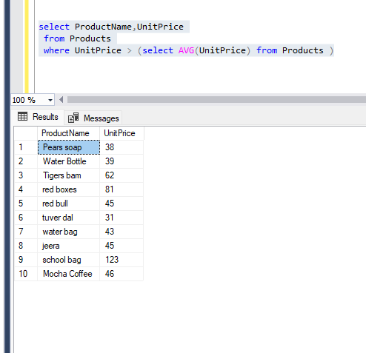

4. Write a query to get Product list (name, unit price) of ten most expensive products

-->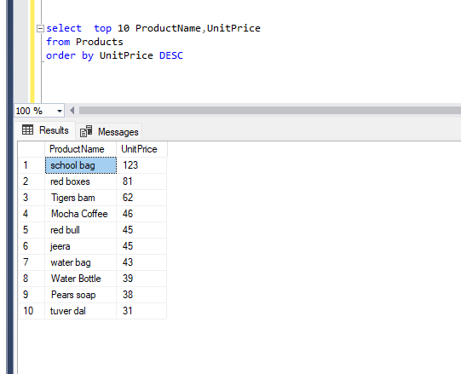

5. Write a query to count current and discontinued products

-->

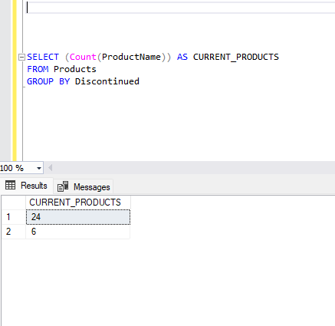

6. Write a query to get Product list (name, units on order , units in stock) of stock is less than the quantity on order.

